**dKOH**

**(Dilute Potassium Hydroxide)**

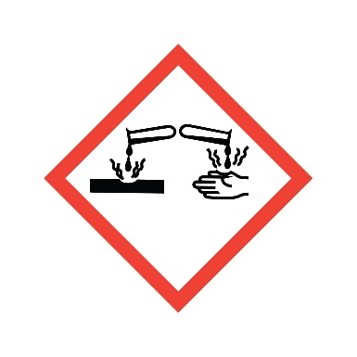

**Danger**

Toxic in contact with skin. Harmful if swallowed.

**Composition**

**KOH + DI Water**